**Order rules**

**BRF Svejk**

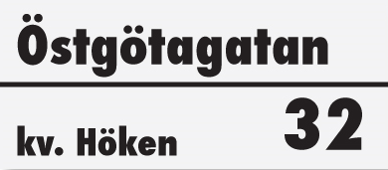

# Why do we need order rules?

**Order rules can in many ways increase the well-being in our tenant- owners association. The order rules do not only apply to tenant-owners but also to second-hand tenants. The association’s Board has written this document in order to make it easier for members and secondary tenants to act correctly in our association. It is your responsibility as a tenant-owner to inform your second-hand tenants regarding the rules in our association. The document is available in both Swedish and English on our website,** [**http://www.brfsvejk.se/boendeinfo/**](http://www.brfsvejk.se/boendeinfo/) **. If you rent out second hand, we suggest having the printed document in the apartment so that second-hand tenants can access the information.**

## About general care

* Be aware and well caring for the association's property. Costs for maintenance and repairs are paid jointly by everyone.
* If damage occurs in the house, first of all contact the property caretaker according to the information at the entrance. The property caretaker is on call 24 hours a day and if something acute, such as water damage or flooding occurs, report the damage immediately.

## About security

* Check that the outer gate of the property is locked after your entry and exit. Use the acces tag or the app Parakey (see more under Boendeinfo/Passagesystem on our website).
* Do not allow any unknown person inside the property.
* Make sure that doors such as to the basement, laundry, bicycle and garbage room are locked after you have passed.
* Your apartment must be equipped with a smoke detector.
* Please inform neighbors or the Board if you are away for a long time.
* Fire authorities do not allow bicycles, bags of recycled paper, baby stroller or something alike to be placed in the entrance, basement halls or on the floors.
* It is forbidden to leave building materials or any kind of materials in the common areas for a longer period. See more information about the waste disposal bellow

## About common costs

* Be economical when using hot water and do not leave water running unnecessarily. Water costs are paid jointly by all tenants.
* Tenant-owners should change crane packs if water is dropping. For replacement of crane packing, we recommend the hardware store Järnhörnan on Södermannagatan 46.

## About disturbance

* For everyone to enjoy living in our association, it is important not to be disturbed. All building residents are required to show consideration. This applies inside the apartment but also in common areas such as stairs, garden and laundryroom.
* The rules apply 24 hours a day but are particularly important to follow weekdays from 22:00 to 7:00.
* If you have a party, please inform the neighbors well in advance if you think you are bothering.

## About garbage disposal

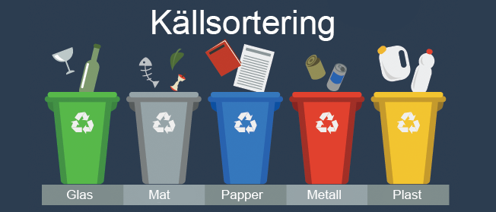

* As a resident, you are obliged to handle the garbage correctly.
* In Sweden, we have high ambitions when it comes to sorting waste and it is therefore very important that we all continue to sort garbage properly.
* All carelessness with mis-sorted and uncompressed waste in the garbage room costs our association a lot of money.
* There are vessels for food, household waste and burnable waste in the garbage room. Follow the signs in the garbage room in order to sort correctly.
* If the vessels are full then you shouldn’t throw your waste there until there is space again.
* Keep in mind that it is forbidden to put garbage outside the garbage vessels or the garbage room.
* At Åsögatan near Götgatan there is a recycling station where you can throw away plastic, paper, metal, batteries, cardboard and other garbage that does not belong in our garbage room.
* Bulky waste must not be left in the waste room. Follow the instructions [Sorteringsguide A-Ö](https://www.stockholmvattenochavfall.se/sorteringsguiden)
* Feel free to use the Tiptapp application or others services to get quick help with waste that you cannot transport by yourself.
* In case of misuse, two cameras are installed in the waste room. Any misuse will result in a charge to the responsible apartment owner.

## The laundry rooms

* Booked washing time should be used no later than a half an hour after the start time.
* There are two laundry rooms in the house. A large laundry room with two washing machines, tumble dryers, drying cabinets, shortage and ironing board that must be booked and a small laundry room with a washing machine and a tumble dryer that cannot be booked.
* Hired cleaning staff or external laundry services are strictly prohibited from using the building’s laundry rooms. Residents who have received permission to rent out their apartment short-term must arrange for clean bed linen and towels through external services. The association and your neighbors should not bear the usage caused by heavy laundry loads such as sheets and towels. Furthermore, this would limit access to the laundry rooms for regular residents.
* Short-term tenants (defined by the Swedish Tax Agency as stays shorter than 112 days, i.e. 16 weeks) may only use the small laundry room.
* After you have finished washing, clean up the machines and empty the filter in the tumble dryer and the one behind the machine.
* Don't forget to remove the key from the booking board.
* The machines in the laundry rooms may only be used between 07:00 and 22:00.
* For further rules in the laundry room see the information available in the laundry room.

## The garden

* The garden can be used by all members and their guests. Here apply the same rules as in the rest of the property.
* For whipping and weathering of carpets, bedding etc. there are whipping bars on the garden.

## Apartment maintenance

* Homeowners are responsible for maintaining the apartment.
* What is included in the apartment and which is to be maintained is stated in the association's statutes. You can find them on our website: <http://www.brfsvejk.se/boendeinfo/stadgar/>.
* If something breaks in the apartment, make sure it is repaired.
* It is especially important that you supervise the apartment's wet areas. Leakage damage is expensive and it generally leads to great discomfort for the person affected.

## No smoking in common areas

* Smoking may not take place in Brf Svejk's common areas, ie. smokers are directed to the street outside our entrance (alternatively inside the condominium owner's apartment).

**Do you have questions? Contact the Board**.

**styrelsen@brfsvejk.se**